Experience
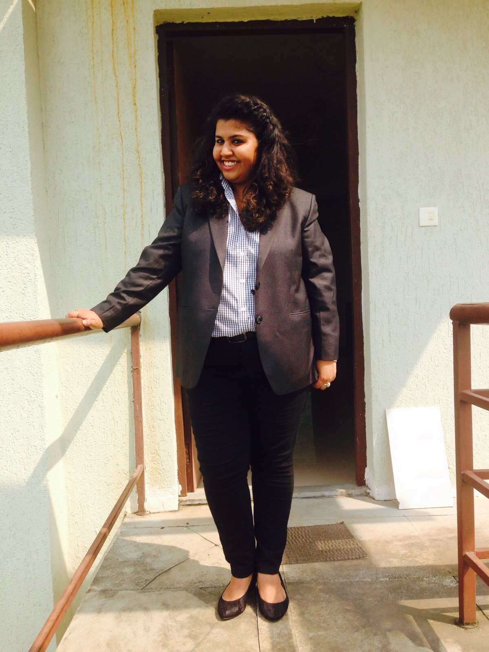
Priyanka banerjee

Objective
To enter an impeccable relationship with a result-oriented organization which can utilize the experiential skills and knowledge of an individual and provide a challenging and dynamic work environment with good amount of freedom and corresponding work responsibility.

Skills & Abilities
- Digital Media Skills: Blogging,
Content Curation, SEO, SMM.
- Basic MS office
- Creative skills: Infographics, Sketching.
- Verbal and written communication
- Punctual and self-motivated
- Interpersonal Skills.

Vitals
 B-13, Shashi Garden, Gali No-4, Mayur Vihar phase 1, Delhi - 110091
7875734290; 9873977223
priyanka.banerjee51@gmail.com

Xebec Communication, Pune

May 2016- july 2016
Social Media Intern: create, curate and manage all the published contents, traffic analysis, running campaigns, handling social media platforms- Instagram, Facebook, Twitter, LinkedIn

project

Gomc (google online marketing channel)
Identifying business, develop and communicate successful business campaigns, blogging and run an online advertising campaign addressing target groups on social media platforms.

Education

Universal Business school, Mumbai, pgdm

2015-17

Dyal singh college, delhi, b.sc.

2011-14

raisina bengali SCHOOL , delhi, x^{th} & XIIth

2009 & 2011

LEADERSHIP
- Assistant PR of Astitva- Dyal Singh College’s Theatre Society 2011-2014
- Chief Organizer of “Treasure Hunt” contests during Rush4Rush in Universal Business School 2016 & 2017
- Promotional Head for the inter-college Business Adventure Fest- ‘Rush4Rush’ in Universal Business School 2016 & 2017
- One of the content writer for college’s annual fest website Rush4Rush in Universal Business School. 2016

Hobbies
- Reading.
- Sketching.
- Dramatics.
- Reciting Bengali poems



